The department having slary greater than 10000

1. In sql
2. Select deptno, sum(salary) from employee group by deoptno having sum(salary)>10000
3. In data flow
4. Create everything same as created previously
5. Now go to aggregate and add deptno in group by
6. Click on + after aggregate select filter

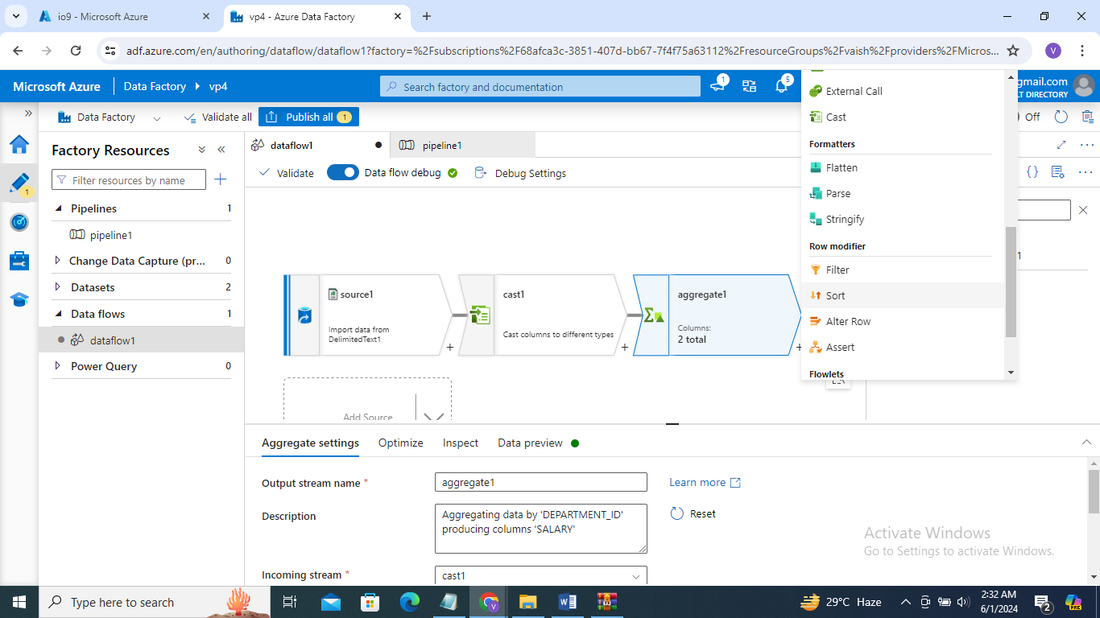

1. Go to filter on

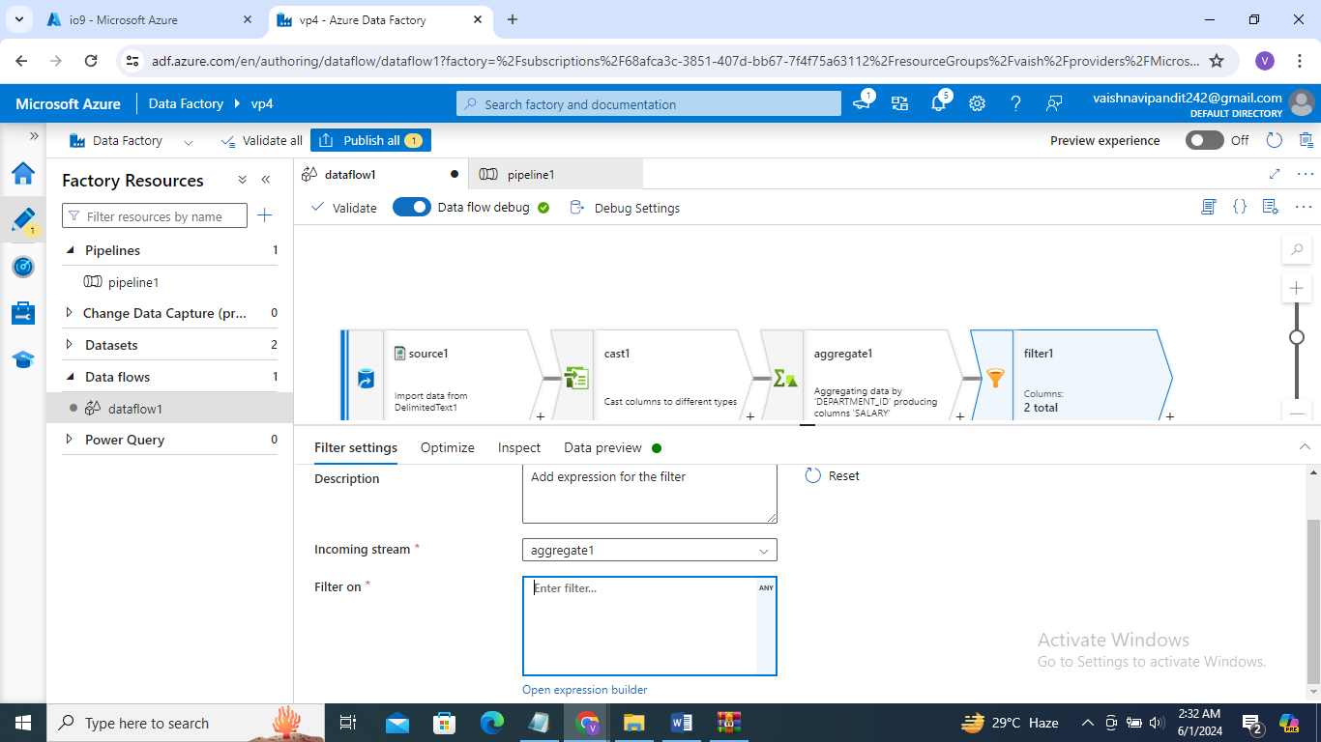

1. Go to open expression builder

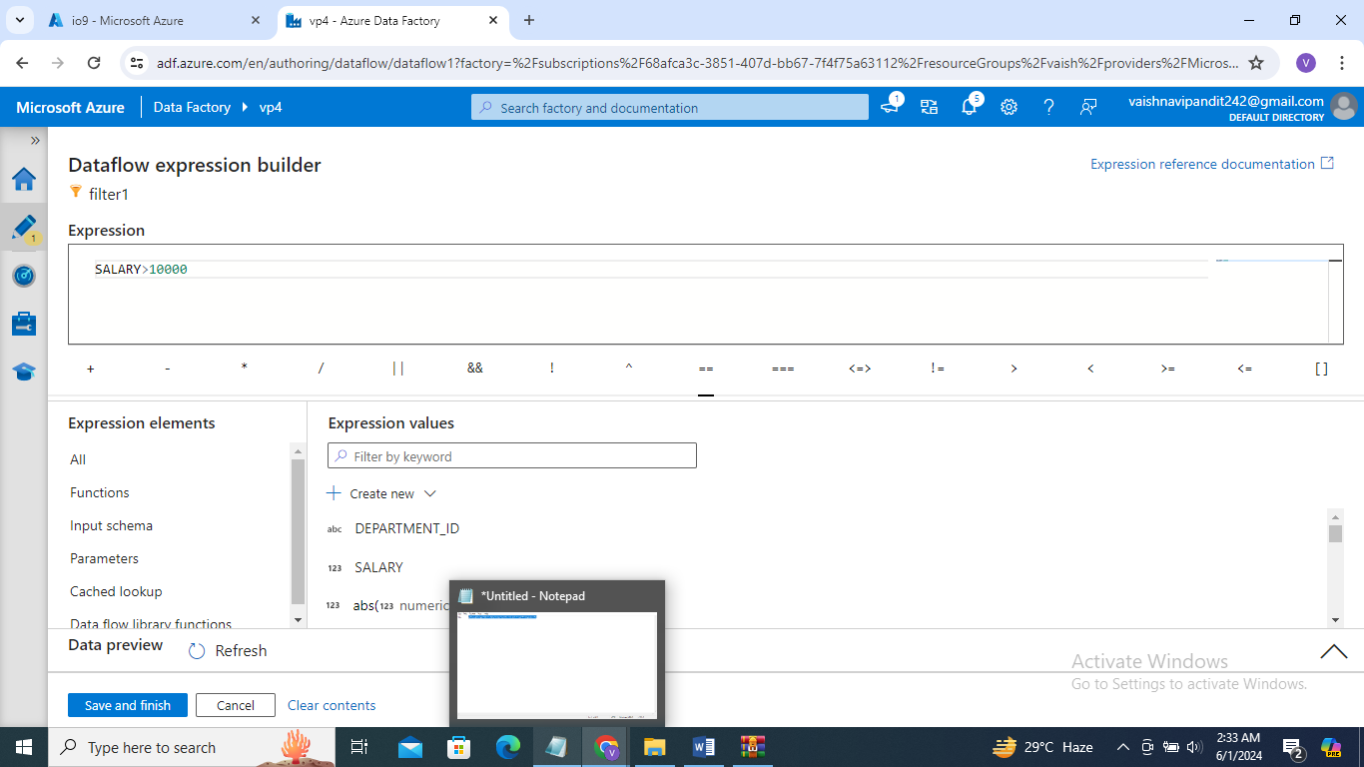

1. Add sink pipeline debug publish